**System Flowchart**

Figure * shows the process of the proposed system JRMSU Research Development and Extension Portal With Plagiarism Detector. The following images is a step by step process in which to identify the flow of the system. The first step is admin, admin has the 2 different attributes first is add account from the Unit Head or Chairperson from the different campuses in order for the Unit Head or Chairperson to access the login information with the given username and password from the admin. Second is Add research status or data that can be encoded in a given system, after adding a data it allows the admin to add the author account which the author can show their works. The second step of a system is Unit Head. The unit head has the attributes of adding account of the chairperson and adding research status. The unit head is only allowed to add research in their campuses only. It can also manage the accounts and data that has been encoded by the chairperson by only their campus. After adding a research status it allows to add author account otherwise it will automatically rejected. And the third step is the chairperson, chairperson only add research status and author if and only if the chairperson add the research status. And also it allow to manage the account of the author in which that the chairperson added. And the last step is author. author is only can view their research works. In addition the author also capable to set their research works into public that anybody can see it otherwise retrieve.

In this system, people may view all the research and extension works that was publicize by the author by accessing in this system. People also view the author and the status of the research or extension and download the research or extension documents.

The image below that has red border is the process of admin and the green border is for unit head and the orange is for chairperson and violet for author.

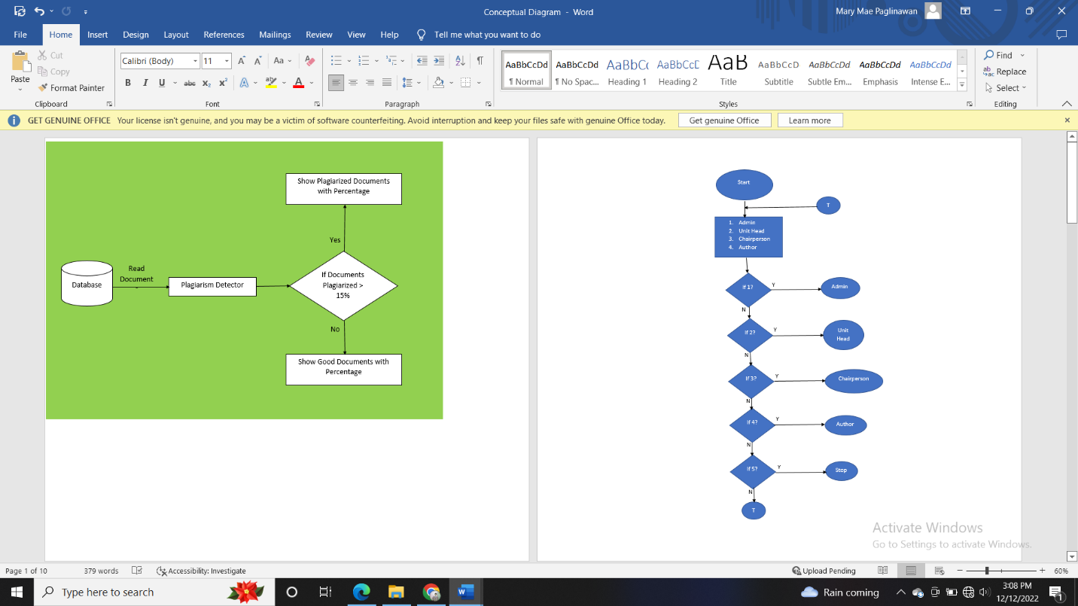,

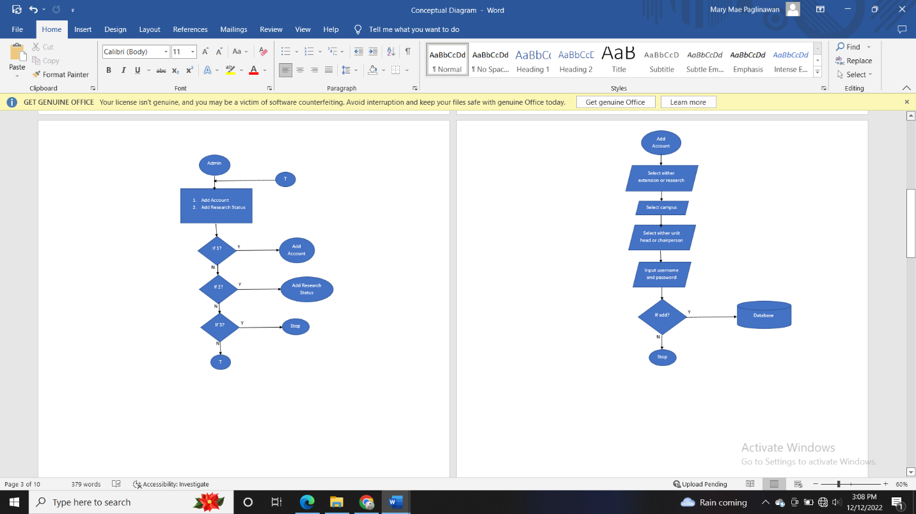

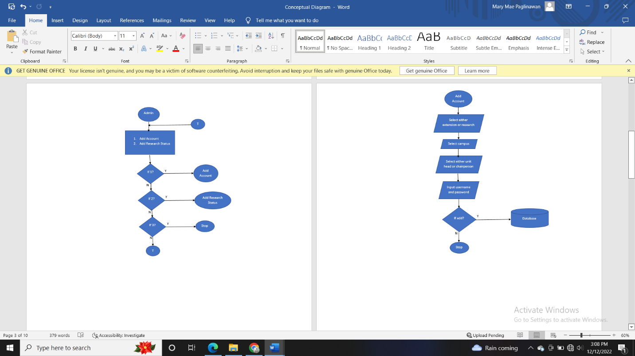

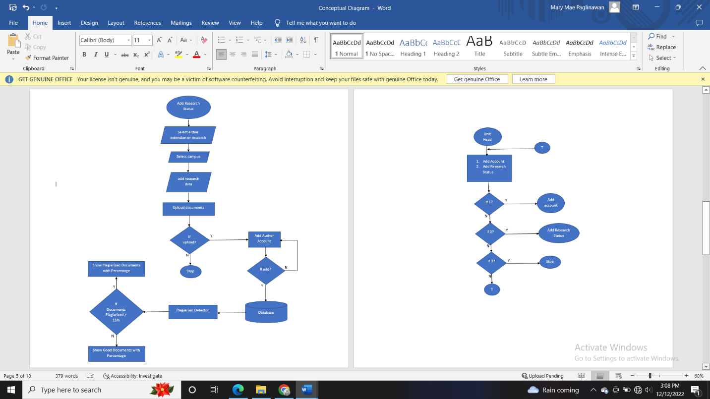



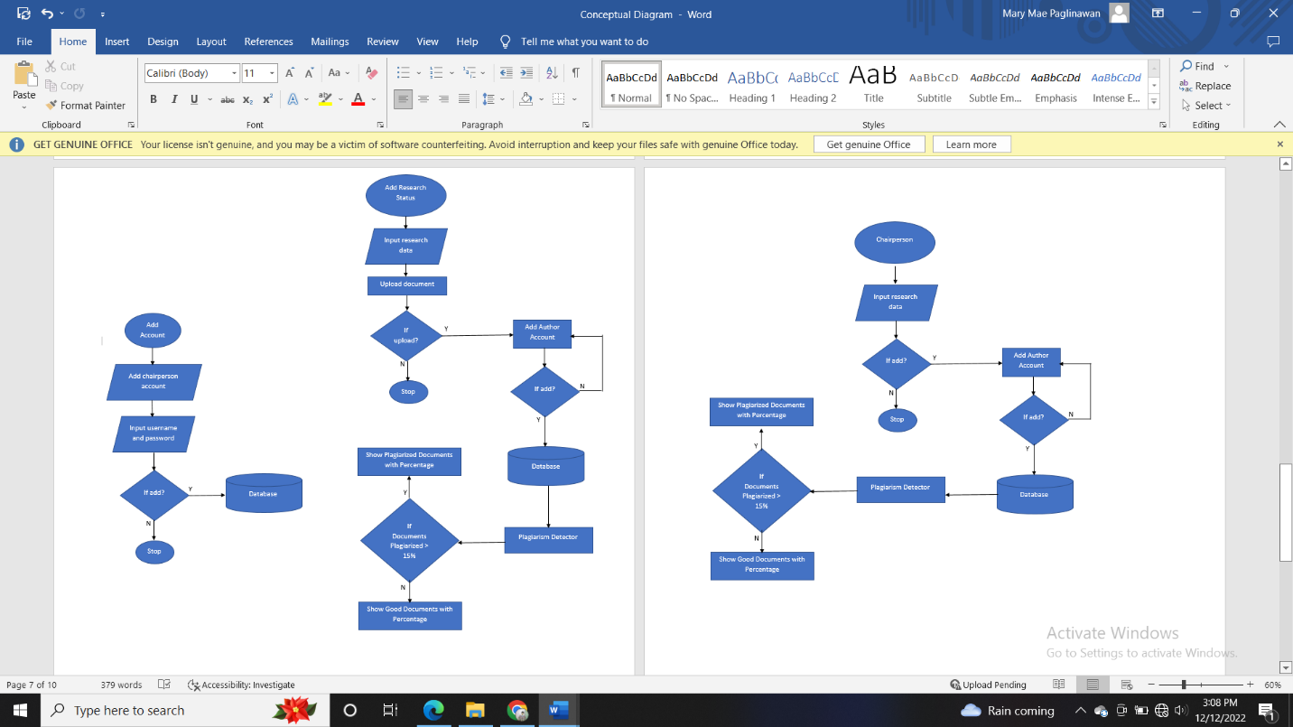





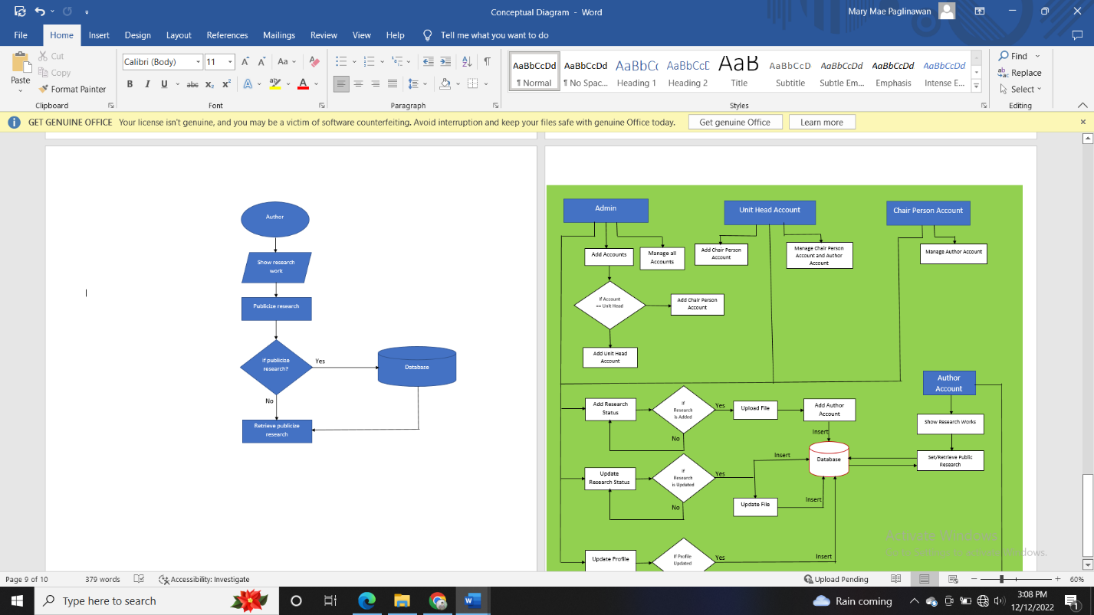

Figure *. System Flowchart.

Entity Relational Diagram

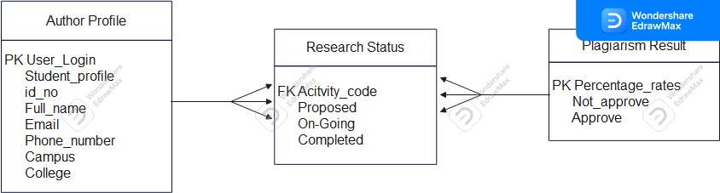

Class Diagram

